Linux 접속
> putty > Connection > SSH >
Auth > Credentials > Private Key 선택
ubuntu 로 접속
$ su root
$ docker ps
docker container 접속
$ docker exec -it mysql_server /bin/bash
mysql 접속
$ mysql -uroot -p
mysql > show databases;
mysql > use onestar;
mysql > show tables;
mysql > select * from [table 명];
CREATE DATABASE jane;
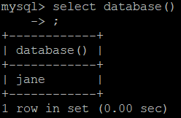
집계함수
-- 판매 데이터를 저장할 테이블 생성
CREATE TABLE sales (
id INT,
salesperson VARCHAR(50),
region VARCHAR(50),
amount INT
);

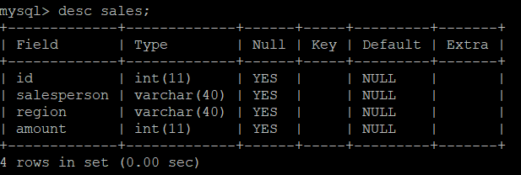

-- 테스트용 데이터 삽입
INSERT INTO sales (id, salesperson, region, amount) VALUES
(1, 'Alice', 'Seoul', 100),
(2, 'Alice', 'Seoul', 200),
(3, 'Bob', 'Busan', 150),
(4, 'Bob', 'Busan', 300),
(5, 'Charlie', 'Seoul', 180),
(6, 'Charlie', 'Busan', 120);
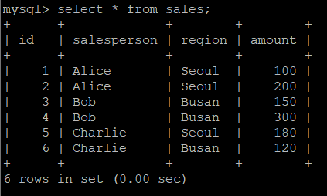

-- 전체 판매 금액의 총합을 구함
SELECT
SUM(amount) AS total_amount
FROM sales;
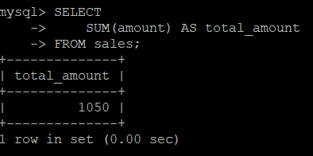
-- 전체 판매 금액의 평균을 구함
SELECT
AVG(amount) AS average_amount
FROM sales;
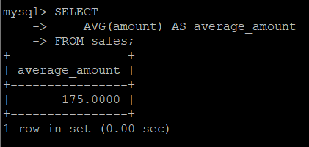

-- 판매 금액 중 가장 작은 값을 구함
SELECT
MIN(amount) AS min_amount
FROM sales;
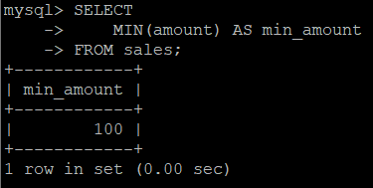
-- 판매 금액 중 가장 큰 값을 구함
SELECT
MAX(amount) AS max_amount
FROM sales;
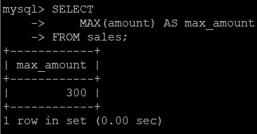
CREATE TABLE Orders ( OrderID INT PRIMARY KEY, CustomerID VARCHAR(10), ProductName VARCHAR(50), Amount INT );

INSERT INTO Orders (OrderID, CustomerID, ProductName, Amount) VALUES (1, 'C001', 'Laptop', 1500000),
(2, 'C002', 'Smartphone', 1000000), (3, 'C003', 'Tablet', 700000), (4, 'C004', 'Smartwatch', 500000),
(5, 'C005', 'Desktop', 2000000), (6, 'C006', 'Monitor', 700000), (7, 'C007', 'Wireless Earbuds', 300000), (8, 'C008', 'Smartphone', 1000000), (9, 'C009', 'Tablet', 700000);

ROW_NUMBER()
SET @row_num := 0;

SELECT
OrderID,
Amount,
@row_num := @row_num + 1 AS RowNum
FROM Orders
ORDER BY Amount DESC;
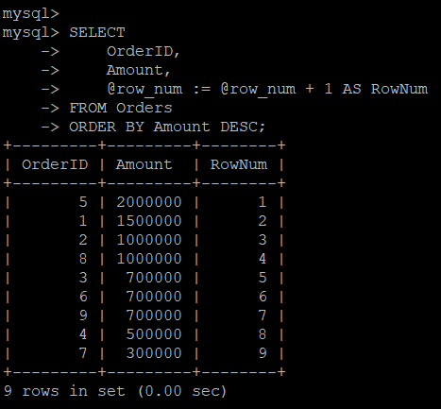
RANK();
SET @rank := 0;
SET @prev_amt := NULL;
SET @count := 0;

SELECT
OrderID,
CustomerID,
ProductName,
Amount,
@rank := IF(@prev_amt = Amount, @rank, @count + 1) AS rank,
@count := @count + 1,
@prev_amt := Amount
FROM Orders
ORDER BY Amount DESC;
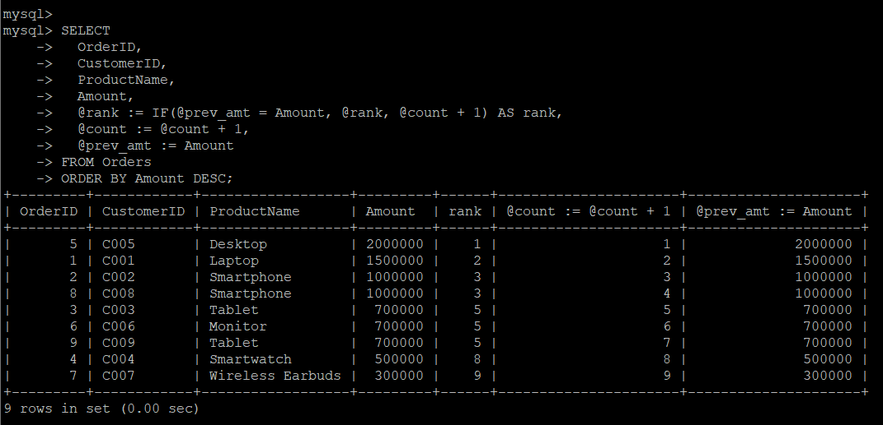

SET @drank := 0;
SET @prev_amt := NULL;

SELECT
OrderID,
CustomerID,
ProductName,
Amount,
@drank := IF(@prev_amt = Amount, @drank, @drank + 1) AS dense_rank,
@prev_amt := Amount
FROM Orders
ORDER BY Amount DESC;
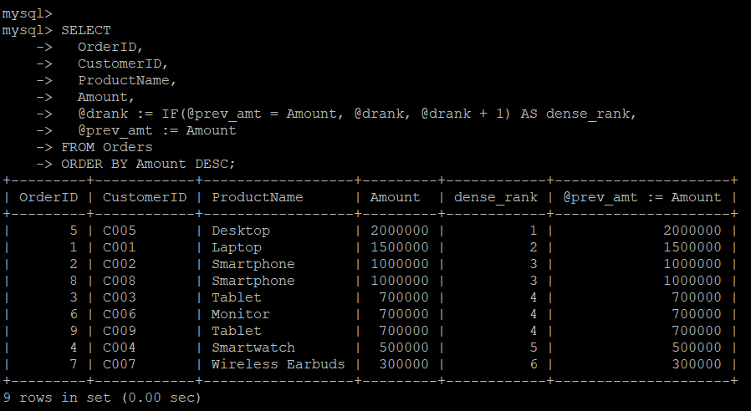
NTILE(n)
SELECT COUNT(*) INTO @total FROM Orders;
SET @n := 4;
SET @per_group := CEIL(@total / @n);
SET @row := 0;

SELECT
OrderID,
CustomerID,
ProductName,
Amount,
FLOOR((@row := @row + 1) / @per_group) + 1 AS ntile_4
FROM Orders
ORDER BY Amount DESC;

